九 角 子
Nine Actors

為華樂團而作
For Zhudi, Pipa and Chinese Orchestra

葉樹堅
Stephen Yip

00/000

九 角 子
Nine Actors

為華樂團而作
For Zhudi, Pipa and Chinese Orchestra

葉樹堅
Stephen Yip

(2011)

10’

九角子
Nine Actors

Copyright © Singapore Chinese Orchestra Ltd. All rights reserved.

版权所有, 未经许可, 不得以任何形式印刷、复制、扫描或发行。
Unauthorised printing, reproduction, scanning or distribution is strictly prohibited
without the express permission of the copyright holder.

Printed in Singapore.

Singapore Chinese Orchestra Ltd.
Singapore Conference Hall,
7 Shenton Way,
Singapore 068810

傳Biography
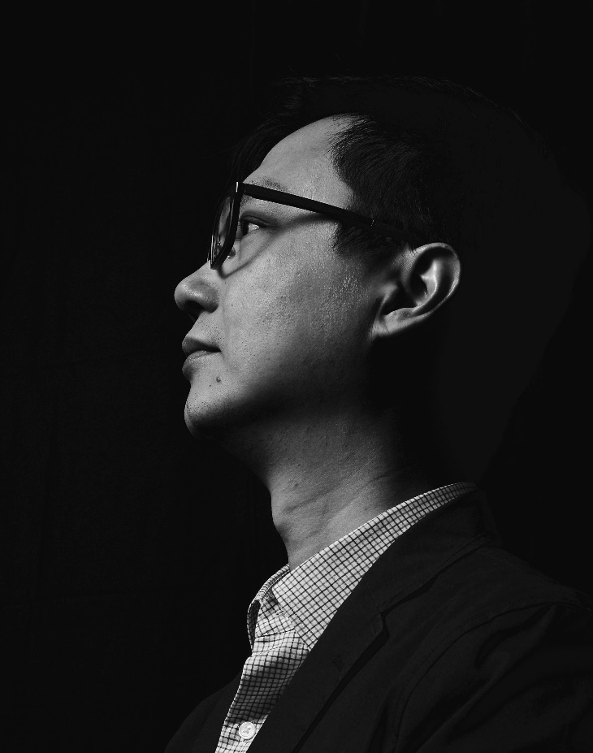
葉樹堅出生於香港，現居美國。畢業於香港演藝學院及美國賴斯大學.他曾參加Aspen音樂節、亞洲作曲家聯盟、Music X、水牛城六月、IMPULS樂團學院、加州E.A.R.作曲家研討會及捷克第十三屆國際夏日節， 亦曾於佛羅裡達州的亞特蘭大藝術中心、內布拉斯加州的甘姆哈丁尼爾遜藝術中心及弗吉尼亞州創意藝術中心擔任駐場藝術家。

他的作品曾於美國、歐洲及亞洲演出。曾獲得的作曲獎項包括Salvatore Martirano 紀念國際作曲獎，新加坡中國樂隊國際作曲獎，2011 臺灣音樂中心TMC國際作曲大賽，Isang Yun國際作曲比賽入選獎，海法國際作曲獎、德布西三重奏音樂基金作曲比賽獎、莫利那尼四重奏的第三屆國際作曲比賽、聖保羅室樂團比賽、及ALEA I作曲比賽等。他的作品經ERM-Media、PARMA、North South recording、ATMAClassical及Beauport Classical等品牌灌錄發行。

葉氏曾跟多個著名樂團合作。包括香港中樂團，香港小交響樂團，香港無極樂團，新加坡中樂團，台灣十方樂集，美國Wellesley composer conference ensemble，美國north/south consonance，美國聖保羅室樂團，瑞典Curious chamber players，德國Ensemble El Perro Andaluz，韓國TIMF ensemble，盧森堡Sinfonietta，俄羅斯新音樂團等。

葉樹堅是作曲家協會(SCI)及香港作曲家及作詞家協會成員，現任教於侯斯頓社區學院音樂系及自由作曲家。

"Stephen Yip has an extraordinary way of creating a post-Darmstadtian modernism that incorporates his Chinese roots with a subtlety that gives us a vivid experience of the inner colors of an advanced spatial sense. It leaves us with a feeling of focused tranquility. He is a genuine voice in new music today." —Gapplegate Classical-Modern Music Review
“…. abound in colourful texture that take their cue from traditional Asian music…. and…. Yip’s splendid ear and sophisticated technique stand him in good stead….”
—Gramophone Review
Stephen Yip (b. 1971)
Born in Hong Kong and now living in U.S.A. He received his Doctor of Musical Arts (D.M.A.) at Rice University and Bachelor of Fine Arts (B.F.A.) at the Hong Kong Academy for Performing Arts. He has attended major music festivals including: Wellesley Composers Conference, Aspen Music Festival, International Summer Course for New Music Darmstadt, Asian Composers’ League, ISCM World Music Days, Chinese Composers’ Festival, Music X, June in Buffalo, IMPULS Ensemble Akademie, California E.A.R. Unit Composer Seminar, the 13th International Summer Program, Czech Republic, International Composers’ Workshop, Luxembourg, the International Summer Course for New Music, Darmstadt, Germany, Wellesley Composers’ Conference. Residencies include: the Atlantic Center for the Arts, Florida, Kimmel Harding Nelson Center for the Arts, Nebraska, Virginia Center for the Creative Arts, Yaddo Colony, NY and the MacDowell Colony, NH.
Yip’s works have been performed in the United States, Canada, Costa Rica, Israel, Austria, Croatia, Czech Republic, Luxembourg, Germany, Italy, Korea, Japan, Indonesia, Hong Kong, Taiwan, Singapore, and Philippines. He has received several composition prizes, included “Earplay”, “Salvatore Martirano Memorial Composition Award”, “Taiwan Music Center International Composition Prize”, “Robert Avalon International Prize”, “Singapore International Composition Competition for Chinese Orchestra”, “Haifa International Composition Prize”, First International EPICMUSIC Composition Prize, Italy, International Biennial composition competition, the Debussy Trio Music Foundation, Molinari Quartet’s Third International Composition Competition, the St. Paul Chamber Orchestra Emerging, the ALEA III composition Competition, the fourth NACUSA Texas Composition Competition, the International Music Prize for Excellence in Composition 2010, by the National Academy of Music, Thessaloniki, Greece, and the 2010 Alvarez Chamber Orchestra Freestyle Composition Competition, London, England .
His works have been performed by major ensembles and players such as Alarm Will Sound, Earplay New Music, Mivos String Quartet, New York New Music Ensemble, Great Noise Ensemble, North South Consonance, Brno Philharmonic Orchestra, inFLUX Duo, Windpipe Chinese Orchestra, Little Giant Chinese Orchestra, Hong Kong Chinese Orchestra, St. Paul Chamber Orchestra, Curious Chamber Players, TIMF Ensemble, Ensemble El Perro Andaluz, Hong Kong Sinfonietta, Singapore Chinese Orchestra, Avanti, Ensemble Kochi, Moscow New Music Ensemble, etc.
Yip’s works are recorded in the Albany, ERM-Media, PARMA, Capstone, North South recording, Ablaze records, ATMA Classique, and Beauport Classical labels. Yip is a member of the SCI, NACUSA, and ASCAP. Currently, he is on the music faculty at Houston Community College and works as a freelance composer.

樂曲介紹Synopsis
此作品《九角子》是取材傳統福建地方戲劇“高甲戲”，實 “九角戲”。“九角戲”是由九個角色組成。作曲家嘗試以九大種潮洲傳統器樂演奏，如嗩吶大小鑼鼓，笛套，絃詩樂，細樂，潮堂樂，等，作九個音樂上的角色。曲中亦節錄福建民謠《苦調》和客民謠《山子歌》作音樂素材。曲中結構以「起」，「承」，「轉」，「合」，「序」，「破」，「急」作曲式。七小段一氣而成把音樂上的聲響和樂韻，將傳統潮洲文化精作現代的啟思。

Nine Actors (九角子) is based on a traditional Fujianese local drama called Gaojia Opera (高甲戲); its original title roughly translating to “Nine Actors’ Opera”, in which said opera would feature nine actors (角). To imitate the nine actors in this piece, the composer has assigned nine traditional Teochew instruments (or instrument groups) to represent these actors. These include: the suona, “drum and gong” ensemble, flute and woodwinds, strings, instrumental solos and court instrumental music, and more.

The piece is divided into seven continuous sections. The first four sections: beginning (起), undertaking (承), change (轉), and togetherness (合) are written in a style of Fujianese folk tunes, while the remaining three sections: order (序), disorder (破) and hast (急), are written in Hakka style folk tunes.

Altogether, Nine Actors covers a wide range of varying tone colour, energetic rhythms and motions that reflect soundscapes that evoke traditional Teochew culture.

編制Instrumentation
梆笛 (Bangdi)
曲笛 (Qudi)
新笛 I (Xindi)

高音笙 (Gaoyin Sheng)
中音笙 (Zhongyin Sheng)
低音笙 (Diyin Sheng)

高音嗩吶 (Gaoyin Suona)
加鍵中音嗩吶 (Jiajian Zhongyin Suona)
加鍵次中嗩吶 (Jiajian Cizhongyin Suona)
低音嗩吶 (Diyin Suona)

管 (Guan)

揚琴 (Yangqin)
柳琴 (Liuqin)
琵琶 I-IV (Pipa I-IV)
中阮 (Zhongruan)
三弦 (Sanxian)
大阮 (Daruan)

古箏 (Guzheng)

定音鼓 (Timpani)
打擊樂 I (Percussion I): 大鼓 (Dagu), 小鼓 (Xiaogu), 排鼓 (Paigu)
打擊樂 II (Percussion II): 南梆子 (Nanbangzi), 木魚 (Woodblocks), 排鼓 (Paigu), 拍板 (Clapper)
打擊樂 III (Percussion III): 大低鑼 Tam(-tam – large), 碰鈴 (Pengling), 大鈸 (Dabo)
打擊樂 IV (Percussion IV): 磬 (Temple Gong), 木琴 (Xylophone), 大低鑼 (Tam-tam – large), 鋁板琴 (Vibraphone), 小鈸 (Xiaobo)
打擊樂 V (Percussion V): 大鈸 (Dabo), 鋼片琴 (Glockenspiel), 小鑼 (Xiaoluo)

高胡 (Gaohu)
二胡 (Erhu)
中胡 (Zhonghu)
大提琴 (Violoncello)
低音提琴 (Contrabass)

